How to Close Caption Using Automatic Captions in YouTube

Brief Summary

This document provides you the information regarding how to close caption using automatic captions in YouTube. Be aware that there is a wait time for automatic captions to become available in YouTube. It can be minutes or hours (sometimes a day) depending on the length of your video and the complexity of your audio track.

Procedure:
Step 1: Sign into YouTube. If you don’t have an account, click <Sign in> in the upper right corner of YouTube, click <Create Account> and enter the required information. Once in your account, click the <Upload> button at the top of the page, select the video you'd like to upload from your computer, and use the default Privacy Setting <Public>.
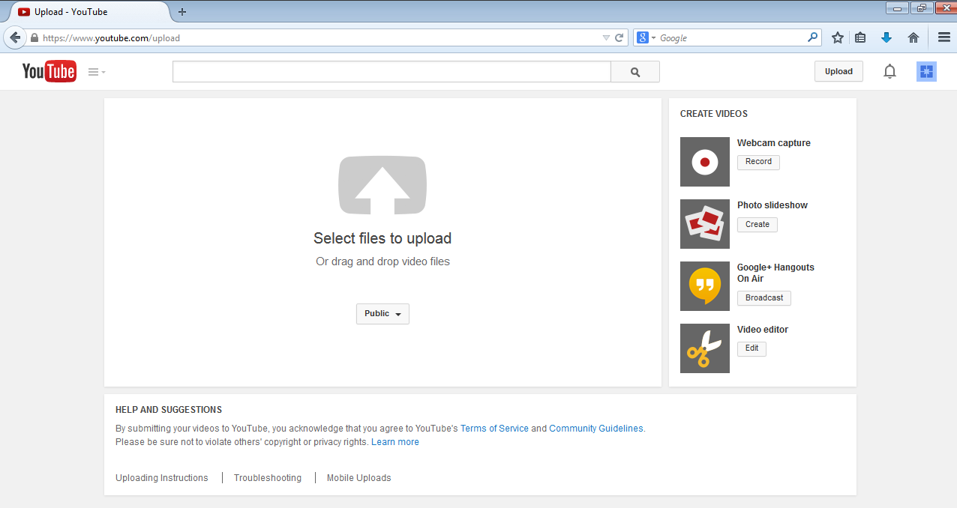
Select Privacy Setting here!
Upload your video here!
Wait until YouTube finishes uploading and processing your video and then click <Publish> to finish uploading it on YouTube. Once the upload is completed YouTube will send you an email to notify you that your video is done uploading and processing. If you prefer not to receive notification, you can opt out by visiting your email settings.

Step 2: To bring the Automatic Captions, go to <CREATOR STUDIO>, <Video Manager> tab in your YouTube account, find the video to caption, select the <Edit> button, and click on the <Subtitles and CC tab>.

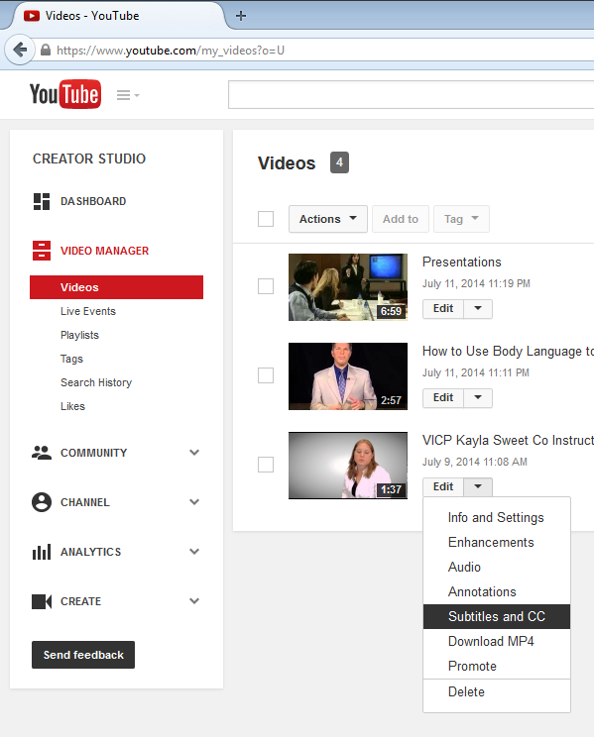
Select Video Manager!

Step 3: Choose the video language from the dropdown menu.

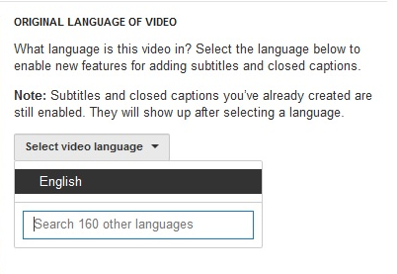

Step 4: If you just uploaded your video, you must WAIT minutes or hours (sometimes a day) for automatic captions to become available in YouTube, depending on the length of your video and the complexity of your audio track.
Wait until the <English (Automatic)> option is available and select it. You might need to refresh the page by selecting the <Add subtitles or CC> button.
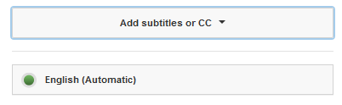
If you waited a day and your video doesn’t have the <English (Automatic)> option available, it might be because your video is too long (more than an hour) or it has poor sound quality or multiple speakers that YouTube doesn't recognize.

Step 5: Although YouTube's automatic captioning is far from perfect, it will get you 60 percent of the way there. Keep in mind, the clearer your speaking voice and diction, the better results you will get. The best part of the automatic captioning tool is the time codes are synched to your content. All you need to do is edit the existing text in each frame.
Step 6: To edit the captioning file, select either if the <Edit> buttons.

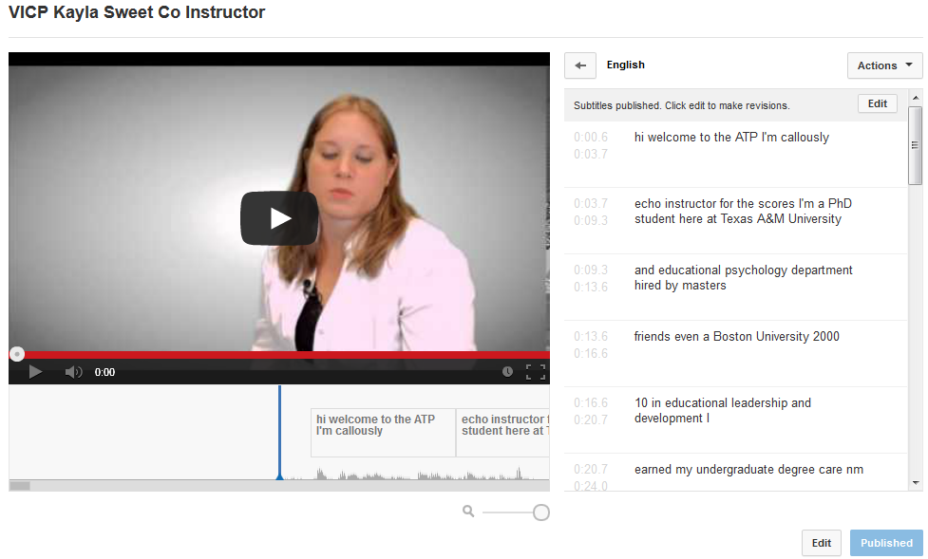

When asked to overwrite existing subtitles files, choose <Overwrite>.
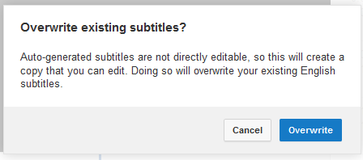
Click inside any line in the caption track panel and edit the text, you can immediately see it reflected in your video.
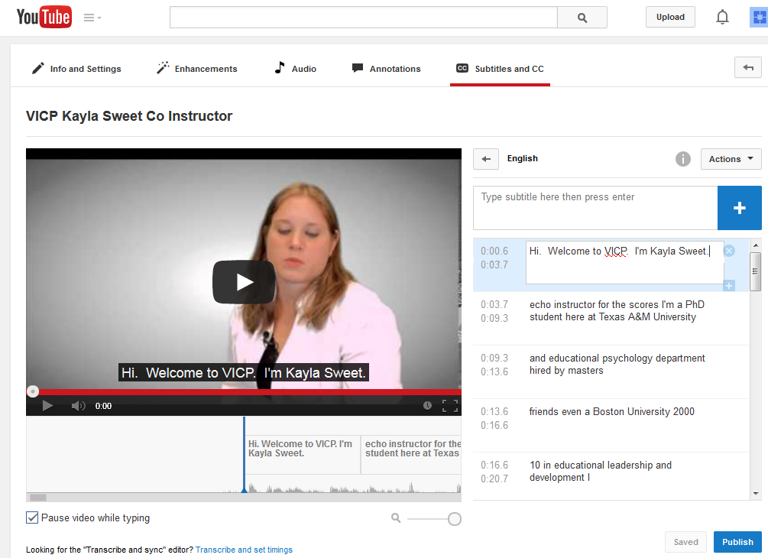
Save file here!

See it reflected on video immediately!

Edit text here!

Frequently, save your work selecting the <Save> button and use the Add <+> and Remove <X> icons to add and remove captions as needed.

Step 7: After completing the captioning edits, select <Publish> to create a new caption file and you will get the message “Subtitles published”.
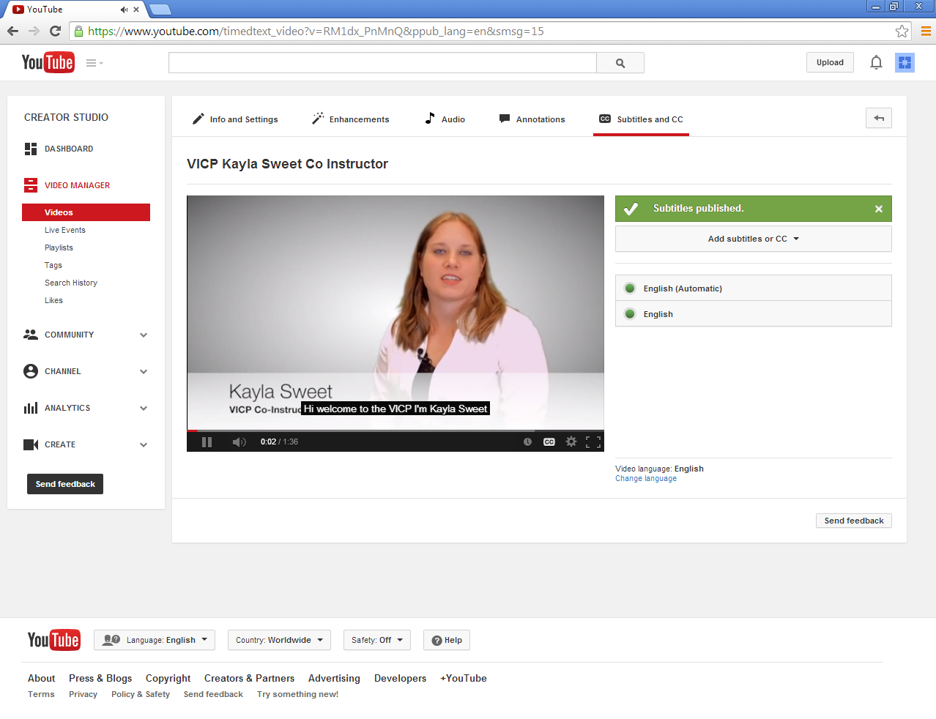
Step 8: Once you have your close captions published, you will need to select the link to include the video in your online course. Click the <Share> link under the video and select <Share this video>, which gives you the link that you want to copy and paste in your online course.
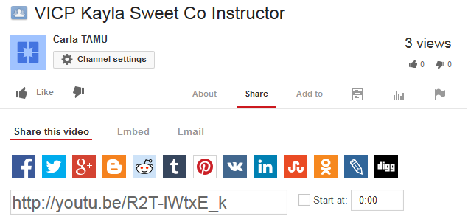
The link to your video is here!

